T2 RC filters and frequency response

2 Preparation

2.1 Understanding of concepts

Q) Write down the equation relating the charge stored in a capacitor to the voltage across it. Differentiate this equation to relate instantaneous capacitor current to capacitor voltage.

A) $Q=CV$

Differentiate $i_{C}=C\frac{dV_{C}}{dt}$ (1)

Q) Using the expression for complex voltage and current and the differential relationship above, derive the impedance of an ideal capacitor.

A) $V_{C}\left(jω\right)=I_{C}\left(jω\right)×Z_{C}\left(jw\right)$

Because $V_{C}\left(jω\right)=V_{0}e^{j(ωt+ϕ)}$

Differentiate $\frac{dV_{C}}{dt}=V_{0}jωe^{j(ωt+ϕ)}$

Substitute $Z_{C}\left(jω\right)=\frac{V_{C}(jω)}{I_{C}(jω)}=\frac{V_{C}}{C\frac{dV_{C}}{dt}}=\frac{V_{0}e^{j(ωt+ϕ)}}{C×V_{0}jωe^{j(ωt+ϕ)}}=\frac{1}{jωC}=\frac{-j}{Cω}$

Q) The time constant for an RC circuit is $τ=RC$. Explain how you would determine the time constant of the waveform shown in Figure 3.

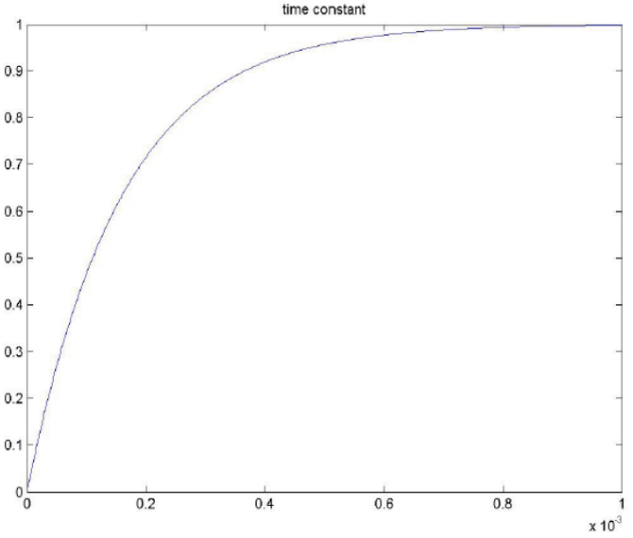

Figure 3 Step response

A) For charging $V_{C}=V_{0}\left(1-ⅇ^{-\frac{t}{RC}}\right)$

For $t=RC$ $V_{c}=V_{0}\left(1-\frac{1}{ⅇ}\right)$

Because $V_{0}=1$, $V_{c}=0.632$

The point corresponding to 0.632V is about

t = 0.15

So time constant $τ=0.15$

Q) Ensure that you are familiar with the MATLAB content of ELEC1200 problem sheet 2 and 3. Review the indicative solutions.

2.2 Relationship of the simulated behaviours to laboratory measurements

Q) Given that signal generator controls and readouts usually give the amplitude of sinusoidal outputs in $V_{rms}$, what generator setting is required to produce an (open-circuit) voltage with a peak value of 1.0V?

A) $V_{RMS}=\frac{V_{pk-pk}}{\sqrt{2}}=\frac{1.0}{\sqrt{2}}=0.707 V$

Q) If you are using an oscilloscope to observe signals in a circuit where the resistance is of the order of $kΩ$, the capacitance is of the order of tens of $nF$ and the frequencies to be observed are below $100kHz$, will you need to use your $×10$ high-impedance probe, or will the $×1$ leads available on the bench be adequate?

A) Original $τ=RC=1000×10×{10}^{-12}=1×{10}^{-8}$

For $×1$ probe $τ=RC=\frac{1}{\frac{1}{1000}+\frac{1}{1000000}}×10×{10}^{-12}=9.990×{10}^{-9}$

For $×10$ probe $τ=RC=\frac{1}{\frac{1}{1000}+\frac{1}{10000000}}×10×{10}^{-12}=9.999×{10}^{-9}$

I will use what is easier to get, because a $×1$ probe won’t have a noticeable effect on the circuit.

2.3 Values and preliminary analysis

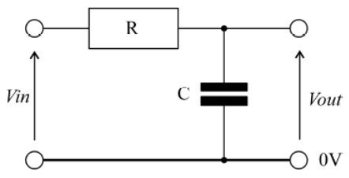

Figure : Simple RC circuit

Q) The nearest preferred values (NPVs) to a $0.1μF$ capacitor and a $1.59kΩ$ resistor assuming that capacitors are limited to E6 (20% tolerance) values and resistors to E12 (10% tolerance) values. Show that equation (1) of section 3.1 below represents the relationships between input and output voltages for the circuit of Figure 1 below.

$\frac{V_{out}(jω)}{V_{in}(jω)}=\frac{\frac{1}{jωC}}{R+\frac{1}{jωC}}=\frac{1}{1+jωCR}=\frac{1}{1+j2πfCR}$ (1)

A) E6 series: 10, 15, 22, 33, 47, 68

E12 series: 10, 12, 15, 18, 22, 27, 33, 39, 47, 56, 68, 82

$0.1μF$ (E6): Choose $100nF$

$1.59kΩ$ (E12): Choose $1.5kΩ$

For the equation (1): $V_{out}=V_{C}$

So by KCV, $\frac{V_{out}(jω)}{V_{in}(jω)}=\frac{V_{C}}{V_{in}}=\frac{Z_{C}}{Z_{C}+Z_{R}}=\frac{\frac{1}{jωC}}{R+\frac{1}{jωC}}=\frac{1}{1+jωCR}=\frac{1}{1+j2πfCR}$

Q) Work out the magnitude and phase of the output voltage in Figure 1 when the input voltage is a 1V peak sinusoid of frequencies 100Hz, 500Hz, 1kHz, 5kHz and 10kHz. Produce a table showing the predicted magnitude and phase and leave columns for the simulated (from Sections 3.2, 3.3) and observed (from Section 3.4) results.

A) Use formula $\frac{V_{out}(jω)}{V_{in}(jω)}=\frac{1}{1+j2πfCR} => V_{out}(t)=Re(\frac{1}{1+j2πfCR})$

|  |  |  |  |
| --- | --- | --- | --- |
| Frequency / Hz | Predicted / V | Simulated / V | Observed / V |
| 100 | 0.990 |  |  |
| 500 | 0.800 |  |  |
| 1k | 0.500 |  |  |
| 5k | 0.0385 |  |  |
| 10k | 0.00992 |  |  |